Session Tracking in Servlets->

**Session** simply means a particular interval of time.

**Session Tracking** is a way to maintain state (data) of an user. It is also known as **session management** in servlet.

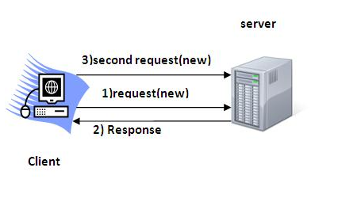

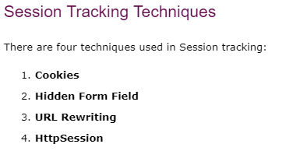

# Cookies in Servlet->

# 

# A cookie is a small piece of information that is persisted between the multiple client requests.

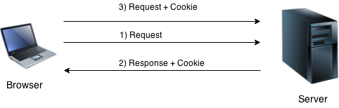

### **Types of Cookie**

There are 2 types of cookies in servlets.

1. Non-persistent cookie
2. Persistent cookie

### **Non-persistent cookie**

It is **valid for single session** only. It is removed each time when user closes the browser.

### **Persistent cookie**

It is **valid for multiple session** . It is not removed each time when user closes the browser. It is removed only if user logout or signout.

### **How to create Cookie?**

Cookie ck=new Cookie("user","sonoo jaiswal");//creating cookie object

response.addCookie(ck);//adding cookie in the response

